 | 26.9.6 Editors - Properties Editor - Modifiers Properties Tab - Curve&Text - Generate Modifiers
Table of content
Detailed table of content 1
Curve&Text - Generate modifiers 6
Array 6
Bevel 8
Build 14
Decimate 15
Edge Split 16
Geometry Nodes 17
Mirror 18
Remesh 19
Screw 21
Solidify 22
Subdivision Surface 26
Triangulate 27
Weld 28

Detailed table of content

Detailed table of content
Detailed table of content 1
Curve&Text - Generate modifiers 6
Array 6
Fit Type 6
Fixed Count 7
Fit Length 7
Fit Curve 7
Relative Offset 7
Factor X/Y/Z 7
Constant Offset 7
Distance X/Y/Z 7
Object Offset 7
Object 7
Merge 7
Distance 8
First and Last Copies 8
UV's 8
Offset U/V 8
Caps 8
Cap Start / End 8
Bevel 8
Affect 8
Vertices 8
Edges 8
Width Type 8
Offset 9
Width 9
Depth 9
Percent 9
Absolute 9
Amount 9
Segments 9
Limit Method 9
None 9
Angle 9
Angle 9
Weight 9
Vertex Group 10
Vertex Group 10
Invert 10
Profile 10
Super Ellipse 10
Shape 10
Custom 10
Miter Shape 10
Custom Profile 11
Preset 11
Zoom in 11
Zoom out 11
Tools 11
Reset View 11
Reset Curve 11
Reverse Path 11
Toggle Profile Clipping 11
Curve view 11
Handle Type Auto Handle 11
Handle Type Vector Handle 11
Handle Type Free Handle 11
Handle Type Aligned Free Handle 11
X Y Values 12
Delete 12
Sample Straight Edges 12
Sample Even Lengths 12
Geometry 12
Miter Inner 12
Sharp 12
Arc 12
Outer 12
Sharp 12
Patch 12
Arc 13
Intersections 13
Clamp Overlap 13
Loop Slide 13
Shading 13
Harden Normals 13
Mark 13
Seam 13
Sharp 13
Material Index 14
Face Strength 14
None 14
New 14
Affected 14
All 14
Build 14
Start 14
Length 14
Reversed 14
Randomize 15
Seed 15
Decimate 15
Mode 15
Collapse 15
Ratio 15
Symmetry 15
Triangulate 15
Vertex Group 15
Invert 15
Un-Subdivide 15
Iterations 16
Planar 16
Angle Limit 16
Delimit 16
Normal 16
Material 16
Seam 16
All Boundaries 16
Face Count 16
Edge Split 16
Edge Angle 17
Sharp Edges 17
Geometry Nodes 17
Data Browser 17
Edit box 17
Add Fake User 17
User 17
Add 17
Remove 18
Mirror 18
Workflow 18
Axis 18
Bisect 18
Flip 18
Mirror Object 18
Clipping 18
Merge 19
Bisect Distance 19
Merge Distance 19
Data 19
Mirror U, V 19
Offset U, V 19
Vertex Groups 19
Flip UDIM 19
Remesh 19
Blocks, Smooth, Sharp 20
Octree Depth 20
Scale 20
Sharpness 20
Remove Disconnected 20
Threshold 20
Smooth Shading 20
Voxel 20
Voxel Size 20
Adaptivity 20
Smooth Shading 20
Screw 21
Angle 21
Screw 21
Iterations 21
Axis 21
Screw 21
Axis Object 21
Object Screw 21
Steps Viewport 21
Render 21
Merge 21
Merge Distance 21
Stretch UV's 21
Normals 22
Smooth Shading 22
Calculate Order 22
Flip 22
Solidify 22
Mode 22
Simple 22
Thickness 22
Offset 22
Even Thickness 22
Rim 23
Fill 23
Only Rim 23
Complex 23
Thickness Mode 23
Fixed 23
Even 23
Constraints 23
Boundary 23
None 23
Round 24
Flat 24
Thickness 24
Offset 24
Merge Threshold 24
Rim 24
Fill 24
Only Rim 24
Vertex Group 24
Invert 24
Factor 24
Flat Faces 25
Normals 25
Flip Normals 25
High Quality Normals 25
Materials 25
Material Offset 25
Rim 25
Edge Data 25
Inner 25
Outer 25
Rim 25
Bevel Convex 25
Thickness Clamp 25
Clamp 25
Angle Clamp 26
Output Vertex Groups 26
Shell 26
Rim 26
Subdivision Surface 26
Type 26
Catmull-Clark 26
Simple 26
Levels Viewport 26
Render 27
Optimal Display 27
Advanced 27
Quality 27
UV Smooth 27
Smooth, keep corners 27
Sharp 27
Use Creases 27
Triangulate 27
Quad Method 27
Beauty 27
Fixed 27
Fixed Alternate 28
Shortest Diagonal 28
Polygon Method 28
Beauty 28
Clip 28
Minimum Vertices 28
Keep Normals 28
Weld 28
Mode 28
All 28
Connected 28
Distance 28
Only Loose Edges 28
Vertex Group 28
Invert 29

Curve&Text - Generate modifiers

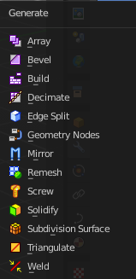

Array
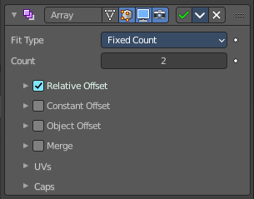
The Array modifier creates an array of copies of the base object. Each copy can offset from the previous one in any of a number of possible ways. Vertices in adjacent copies can be merged if they are nearby, allowing smooth Subdivision Surface frameworks to be generated.
This modifier can be useful when combined with tillable meshes for quickly developing large scenes. It is also useful for creating complex repetitive shapes.
Multiple Array modifiers may be active for an object at the same time. This allows to create complex three-dimensional constructs.
Hint for Offset Calculation. The transformation applied from one copy to the next is calculated as the sum of the three different components (Relative, Constant and Object), each of which can be enabled/disabled independently of the others. This allows, for example, a relative offset of (1.0, 0.0, 0.0) and a constant offset of (0.1, 0.0, 0.0), giving an array of objects neatly spaced along the X axis with a constant 0.1 unit between them, whatever the original object’s size.

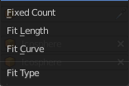
Fit Type
Controls how the length of the array is determined.

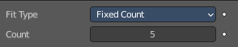
Fixed Count
Generates the number of copies specified in Count.

Fit Length
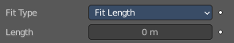
Generates copies to fit within the fixed length given by Length.

Fit Curve
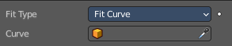
Generates copies to fit within the length of the curve object specified in Curve. You need to select a curve object.

Note! Both Fit Curve and Fit Length use the local coordinate system size of the base object, which means that scaling the base object in Object Mode will not change the number of copies generated by the modifier.

Fit Length uses the local coordinate system length of the curve, which means that scaling the curve in Object Mode will not change the number of copies generated by the modifier.

Applying the scale can be useful for both.

Relative Offset

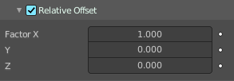
Factor X/Y/Z
Adds a translation equal to the object’s bounding box size along each axis to the offset, multiplied by a scaling factor. X, Y and Z scaling factors can be specified.

Constant Offset

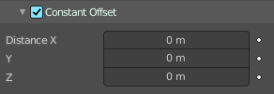
Distance X/Y/Z
Adds a constant translation component to the duplicate object’s offset. X, Y and Z constant components can be specified.

Object Offset
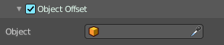
Adds a transformation taken from a chosen object relative to the current object to the offset.

Object
Choose an object.

Merge
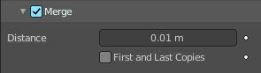
If enabled, vertices in each copy will be merged with vertices in the next copy that are within the given Distance.

Distance
The merge distance between the vertices. Vertices below this distance will be merged.

First and Last Copies
Merge vertices in first and last duplicates.

UV's

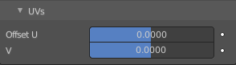
Offset U/V
Shifts UV's of each new duplicate by a settable amount.

Caps

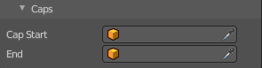
Cap Start / End
Adds a chosen mesh at the start and end of the array. The start object is added at position -1. The end object at position +1. When Merge is activated, and the cap vertices are within the Distance threshold, they will be merged.
Note! The start/end cap objects currently do not support the First and Last Copies option.

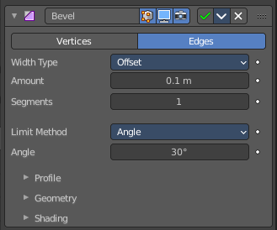
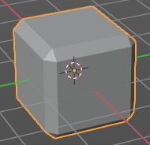
Bevel
The Bevel modifier bevels the edges of the mesh. It is a non-destructive alternative to the Bevel Operation in Edit Mode.

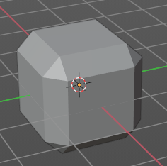
Affect

Vertices
Only the areas near vertices are beveled, the edges remain unchanged.

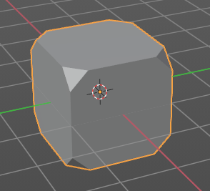
Edges
Bevels both edges and vertices.

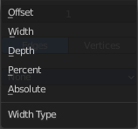
Width Type
Defines how Width will be interpreted to determine the amount of bevel.

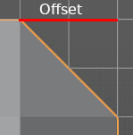
Offset
Value is interpreted as the distance from the original edge to the edge of the beveled face.

Width
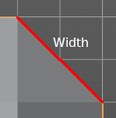
Value is interpreted as the distance between the two new edges formed by the bevel.

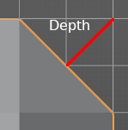
Depth
Value is the perpendicular distance from the new bevel face to original edge.

Percent
Similar to Offset but the value is interpreted as a percentage of the adjacent edge length.

Absolute
Amount is absolute along adjacent edge.

Amount
The bevel amount.

Segments
The number of edge loops added along the bevel’s face.

Limit Method
Used to control where a bevel is applied to the mesh.


None
No limit, all edges will be beveled.

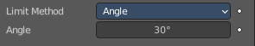
Angle
Only edges where the adjacent faces form an angle smaller than the defined threshold will be beveled. Intended to allow you to bevel only the sharp edges of an object without affecting its smooth surfaces.

Angle
The angle above which to bevel.


Weight
Use each edge’s bevel weight to determine the width of the bevel. When the bevel weight is 0.0, no bevel is applied.

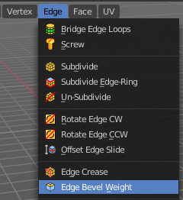
Edge bevel weight can be set in Edit mode in the Edge menu with the Edge Bevel Weight tool.

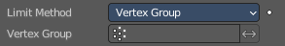
Vertex Group
Use weights from a vertex group to determine the width of the bevel. When the vertex weight is 0.0, no bevel is applied. An edge is only beveled if both of its vertices are in the vertex group. See here about adjusting vertex group weights.

Vertex Group
Choose the vertex group.

Invert
Inverts the influence of the selected vertex group.

Profile
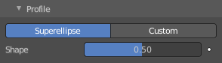
The profile defines the shape of the bevel. Profile has no effect if the number of segments is below 2.

Super Ellipse
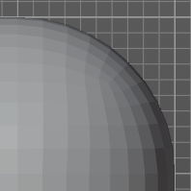
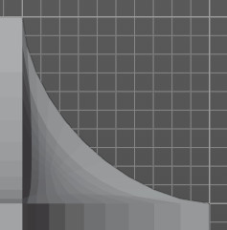
Defines a rounded bevel corner.

Shape
The shape of the rounded bevel corner. A value close to 0 bends the roundness to inside. A value towards 1 bends the curve to outside. A value of 0.5 defines a radius around the center point of the bevel.

Custom
Here you can define a custom shape profile for the bevel.

Miter Shape
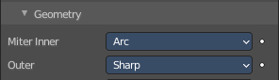
The shape of the custom bevel corner. Has no effect when the miter type is sharp. You need to set it to Arc in the geometry section.

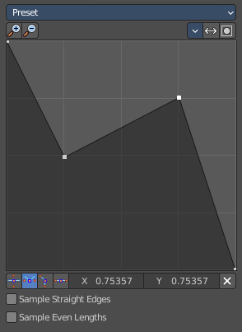
Custom Profile
Choose and adjust a custom bevel profile. This feature needs more than one segment to work.

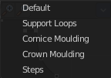
Preset
Choose some profile presets.

Zoom in
Zooms into the curve view.

Zoom out
Zooms out of the curve view.

Tools

Reset View
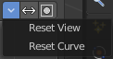
Resets the zoom factor of the curve view.

Reset Curve
Resets the curve to the defaults. This means when you choose a curve preset to reset it to the values of the latest chosen preset.

Reverse Path
The path gets reversed. The first point becomes the last and vice versa.

Toggle Profile Clipping
Toggles the profile clipping.

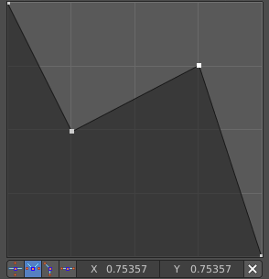
Curve view
Adjust the profile curve.
Left click where no point is adds a new point. Left click at a point allows you to move it.
Holding down Shift while moving a node point activates precision movement.
Holding down ctrl while moving activates temporary snapping.
When a point is selected then the curve view reveals a sub menu at the bottom.

Handle Type Auto Handle
Sets the handle type of this curve point to smooth.

Handle Type Vector Handle
Sets the handle type of this curve point to sharp.

Handle Type Free Handle
Sets the handle type of this curve to Free handles. The curve point has now two handles with which you can adjust the curve before and after the point each.

Handle Type Aligned Free Handle
Sets the handle type of this curve to Free handles. The curve point has now a handle with which you can adjust the curve.

X Y Values
The position of the currently selected curve point.

Delete
Delete the selected curve point.

Sample Straight Edges
Sample edges with vector handles.

Sample Even Lengths
Sample edges with even lengths.

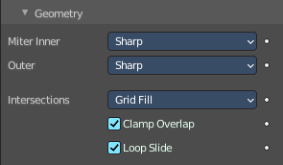
Geometry

Miter Inner
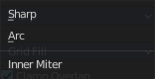
How the inner miter is set. Miter is how the bevel rounding at a corner is done.


Sharp
Creates a sharp miter.

Arc

This replaces the vertex of a miter with 2 vertices, joined by an arc. A separate Spread parameter says how far to move the vertices away from their original position.

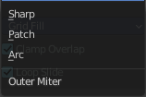
Outer
How the outer miter is set. Miter is how the bevel rounding at a corner is done.

Sharp
Creates a sharp miter.


Patch
This replaces the outside vertex of a miter with 3 vertices. And uses a patch pattern there.

Arc
This replaces the vertex of a miter with 2 vertices, joined by an arc. A separate Spread parameter says how far to move the vertices away from their original position.

Intersections
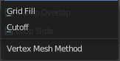
If a bevel corner is filled or not. Needs minimum two segments to have effect.
When the inner corners of the cutoff profiles faces meet at the same location with a three way intersection, then no center face is created.
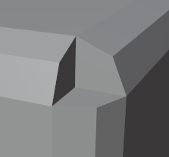
The direction of the cutoff faces depends on the original vertex’s normal.

Clamp Overlap
Limits the width of each beveled edge so that edges cannot cause overlapping intersections with other geometry.

Loop Slide
If there are unbeveled edges along with beveled edges into a vertex, the bevel tries to slide along those edges when possible. Turning the option off can lead to more even bevel widths.

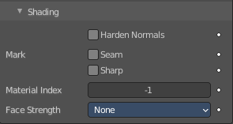
Shading

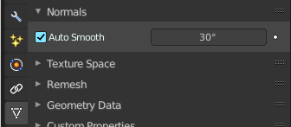
Harden Normals
Match normals of new faces to adjacent faces.
Autosmooth needs to be enabled for this feature. And the shading needs to be smooth.

Mark

Seam
When the beveled edge is a seam edge, then the bevel will also contain a seam to keep the seam into account.

Sharp
When the beveled edge is a sharp edge, then the bevel will also contain a sharp edge to keep the sharp edge into account.

Material Index
The index of the material slot to use for the bevel. When set to -1, the material of the nearest original face will be used.

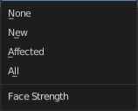
Face Strength
Set the Face Strength on the faces involved in the bevel by the mode specified here.
This face strength then can be used in conjunction with a following Weighted Normals modifier (with the Face Influence option checked).

None
Do not set face strength.

New
Set the face strength of new faces along edges to Medium, and the face strength of new faces at vertices to Weak.

Affected
In addition to those set for the New case, also set the faces adjacent to new faces to have strength Strong.

All
In addition to those set for the Affected case, also set all the rest of the faces of the model to have strength Strong.

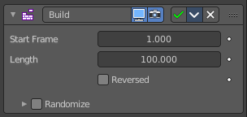
Build
The Build modifier lets the faces of the mesh object to appear or disappear one after the other over time when you play the animation.

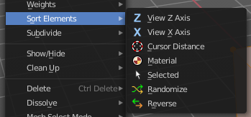
By default, faces appear in the order in which they are stored in memory, which follows the order how they are created. This face/vertex order can be altered in Edit Mode by using Sort Mesh Elements in the Mesh menu.

Start
The start frame of the building process.

Length
The number of frames over which to rebuild the object.

Reversed
The modifier will operate in reverse, and start with the full mesh. And deconstruct it towards the end frame.

Randomize
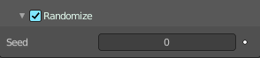
Randomizes the order in which the faces are built.

Seed
The random seed. Changing this value gives a different “random” order when Randomize is checked. This order is always the same for a given seed/mesh set.

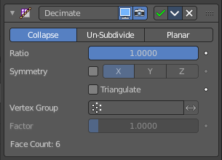
Decimate
The Decimate modifier allows you to reduce the vertex/face count of a mesh with minimal shape changes. The result is just displayed in Object mode. In Edit mode the unaltered mesh is shown.

Mode

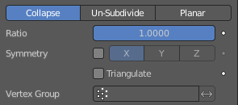
Collapse
This algorithm uses progressive merging of vertices, taking the shape of the mesh into account.

Ratio
The ratio of faces to keep after decimation. 1.0 is not altered. The lower the value the stronger the reduction.
Note! Although the Ratio is directly proportional to the number of remaining faces, triangles are used when calculating the ratio.
This means that if your mesh contains quads or other polygons, the number of remaining faces will be larger than expected, because those will remain unchanged if their edges are not collapsed.
This is only true if the Triangulate option is disabled.

Symmetry
Maintains symmetry on a single axis.

Triangulate
Keeps any resulting triangulated geometry from the decimation process.

Vertex Group
A vertex group that controls what parts of the mesh are decimated.

Invert
Decimate the geometry except the vertex group.

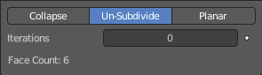
Un-Subdivide
This algorithm tries to unsubdivide divided faces.

Iterations
The number of times to perform the unsubdivide operation. Two iterations is the same as one subdivide operation, so you will usually want to use even numbers.

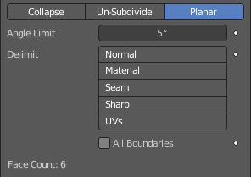
Planar
This algorithm reduces details by unioning adjacent faces that are below an angle limit.

Angle Limit
Dissolve geometry which form angles (between surfaces) higher than this setting.

Delimit
Prevent dissolving geometry in certain places.

Normal
Does not dissolve edges on the borders of areas where the face normals are reversed.

Material
Does not dissolve edges on the borders of where different materials are assigned.

Seam
Does not dissolve edges marked as seams.

All Boundaries
When enabled, all vertices along the boundaries of faces are dissolved.

Face Count
The face count of the decimated mesh.

Edge Split
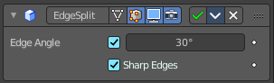
The Edge Split modifier splits single edges into two independent edges when the adjacent faces are below the defined angle. Or when the edge is marked as sharp. Which can be done in edit mode in the Edge menu with the Mark Sharp tool.
Splitting an edge affects vertex normal generation at that edge, and makes the edge appear sharp. So this modifier can be used to achieve the same effect as Auto Smooth. And make edges appear sharp when their angle is above a certain threshold. It can also be used for manual control of the smoothing process, where the user defines which edges should appear smooth or sharp (see Mesh Smoothing for other ways to do this). If desired, both modes can be active at once.
Note! This modifier is kept mostly for historical/compatibility reasons. Everything it can do in shading, and much more, can now be achieved using custom normals. Unless you really need the topology changes it generates, it is not advised to use it in new projects.

Edge Angle
The angle above which to split edges.

Sharp Edges
When you have marked edges as sharp, then these edges will be split.
Note! Non-manifold edges will always be split.

Geometry Nodes
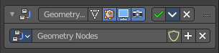
The geometry Nodes modifier adds a geometry node tree, which can be modified in the geometry node editor.

Manage the nodes. If there is no geometry node tree for the current object, then you will see the New button

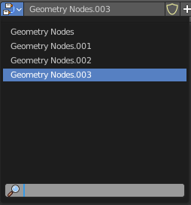
Data Browser
The list of available geometry node trees in the scene.

Edit box
The name of the current active geometry node tree. Here you can also rename the node tree.

Add Fake User
Wit this button you assign a fake user to this selected geometry node tree.
Data, like node trees, that is not longer linked to anything else gets removed when you save and reload a scene. Bforartists has the concept of fake users to go around this behavior. An image with a fake user is in fact linked to something. And so it is not lost when you save and reload the scene.

User
The number of users that uses this data. Data with a user number of 0 will be removed with closing Bforartists.

Add
Add a geometry node.

Remove
Removes the geometry node tree. To delete it completely you need to purge it. See Fake user.

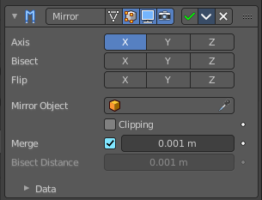
Mirror
The Mirror modifier mirrors a mesh along its local X, Y and/or Z axes, across the Object Origin. It can also use another object as the mirror center, then use that object’s local axes instead of its own.

Workflow
Usually this modifier is used for mirror modeling in edit mode. In Edit mode just the original side is editable then. Recommend is to remove half of the mesh before starting. The missing part will then be added by the Mirror modifier. But you can also use the Bisect feature.

Axis
The axis to mirror along.
You can select more than one of these axes. And will then get more mirrored copies. With one axis you get a single mirror, with two axes four mirrors, and with all three axes eight mirrors.

Bisect
If the mesh is already on both sides of the mirror plane, it is cut by that plane. And only one side (the “negative” one by default) is kept to perform the mirror process.
Note. When you turn Bisect on and pull at the mirror part, then you won't have the mirroring effect to the original side.

Flip
When Bisect is enabled on an axis, you can use this setting to switch the side kept and mirrored (i.e. when it is enabled, the “positive” side will be kept, instead of the “negative” one).

Mirror Object
An Object Selector to select an object (usually an empty), which position and rotation will be used to define mirror planes (instead of using the ones from the modified object).
You can animate it to move the mirror axis.

Clipping
Prevents vertices from moving through the mirror plane(s) when you transform them in Edit Mode.
If it is enabled but vertices are beyond the mirror plane and outside of the Merge Distance, the vertices will not be merged. But as soon as the vertices are within Merge Distance they are snapped together and cannot be moved beyond the mirror plane.
Note! Vertices on the mirror plane will be unable to move away from the mirror plane as long as Clipping is enabled. You must disable it to be able to move the vertices along the mirror axis again.

Merge
Where a vertex is in the same place (within the Merge Distance) as its mirror it will be merged with the mirrored vertex.

Bisect Distance
Vertices are removed up to this distance from the bisect plane.

Merge Distance
The maximum distance between a vertex and its mirror copy at which they are merged together (being snapped on the mirror plane). Needs Merge to be enabled.

Data

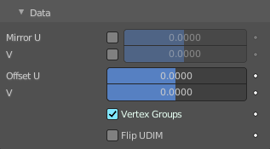
Mirror U, V
Mirror the UV texture coordinates across the middle of the image.

Offset U, V
Offset the UV texture coordinates across the middle of the image.

Vertex Groups
Try to mirror existing vertex groups.
Note! The vertex groups you want to mirror must be named following the usual left/right pattern (i.e. with suffixes like “.R”, “.right”, “.L”, etc.). The mirror side vertex group must already exist (it will not be created automatically). It must also be completely empty (no vertices assigned to it).

Flip UDIM
Mirror the texture coordinates around each tile center.

Remesh
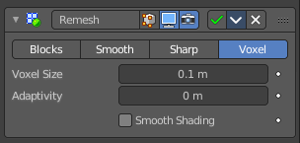
The Remesh modifier generates new mesh topology. The output follows the surface curvature of the input. But its topology contains quads.
The output and also the settings of the three basic modes Blocks, Smooth and Sharp is almost identical. Except the smoothing.

Blocks, Smooth, Sharp
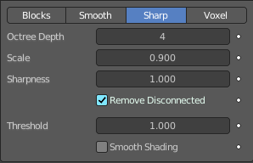
Blocks has no smoothing at all. Smooth outputs a smooth surface. Sharp outputs a smooth surface but preserves sharp edges and corners.

Octree Depth
The resolution of the Octree. Higher values gives finer details.

Scale
The ratio of the largest dimension of the model over the size of the grid.

Sharpness
Sharp mode only. Tolerance for outliers. Higher values produce edges more similar to the input, while lower values filter out noise.

Remove Disconnected
Filter out small disconnected pieces of the output.

Threshold
Use this to control how small a disconnected component must be to be removed.

Smooth Shading
Output faces with smooth shading. The smooth/flat shading of the input faces is not preserved.

Voxel
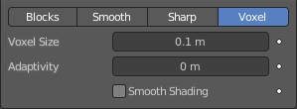
Generate a new manifold mesh from the current geometry while trying to preserve the mesh’s original volume.

Voxel Size
The voxel size. Defines the resolution of the created mesh.

Adaptivity
Reduces the final face count by simplifying geometry where detail is not needed. This feature triangulates faces that do not need as much detail.

Smooth Shading
Output faces with smooth shading. The smooth/flat shading of the input faces is not preserved.

Screw
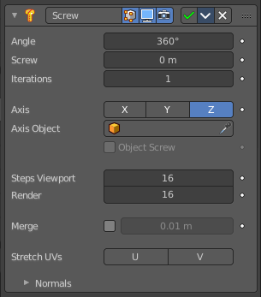
The Screw modifier takes a profile object, a mesh or a curve, to create a helix-like shape.
The profile should be properly aligned to the cardinal direction of the object.

Angle
Degrees for a single helix iteration.

Screw
Offsets the iteration along its axis.

Iterations
Number of iterations.

Axis
The axis along which the helix will be built.

Screw
The height of one helix iteration.

Axis Object
Pick an object to define the axis direction. The helix will then point into the direction of this object.

Object Screw
Use the distance from the Axis Object to define the height of one helix iteration.

Steps Viewport
Number of steps used for a single revolution displayed in the 3D Viewport.

Render
Number of steps used for a single revolution used during render time. Higher values gives higher quality.

Merge
Merge vertices that lie on the axis of rotation. Closes off end points with a triangle fan.

Merge Distance
Vertices under this distance to the axis are merged.

Stretch UV's
Stretch the UV coordinates from (0.0 to 1.0) when UV's are present.

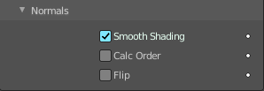
Normals

Smooth Shading
Output faces with smooth shading. The smooth/flat shading of the input geometry is not preserved.

Calculate Order
Order of edges is calculated to avoid problems with normals and shading. Only needed for meshes, not curves.

Flip
Flip normals direction.

Solidify
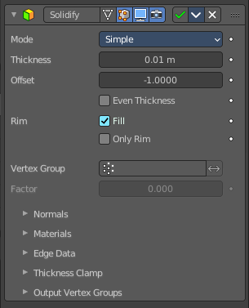
The Solidify modifier adds depth and thickness to the faces of a geometry.
Example. A cube with one face removed.
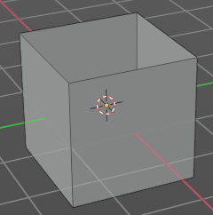
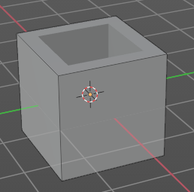

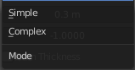
Mode

Simple
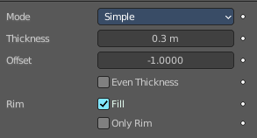
This algorithm simply extrudes the geometry. It does not work on geometry where edges have more than two adjacent faces.
Important! Simple mode will not be able to solidify the boundary between two adjacent faces that does not point into the same direction.

Thickness
The extrude amount.

Offset
A value between (-1 to 1) to locate the solidified output inside or outside the original mesh. The inside and outside is determined by the face normals. Set to 0.0, the solidified output will be centered on the original mesh.

Even Thickness
Maintain the thickness by adjusting for sharp corners.
Note! Solidify thickness is an approximation. The final wall thickness is not guaranteed. The best option to preserve wall thickness is complex mode with constraints thickness mode. But even this is not guaranteed to work perfect in every case.

Rim
Note! Fill and Only Rim only make a difference on Non-manifold objects, since the rims are generated from the borders of the original geometry.

Fill
Fills the gap between the inner and outer edges.

Only Rim
Will not extrude surfaces parallel to the original one, but instead will only add the perpendicular rim.

Complex
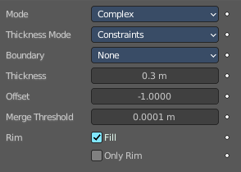
This solidify algorithm can handle every geometric situation to guarantee a manifold output geometry. It is able to solidify shapes like Möbius strips, Klein bottles, architectural wall layouts and many more which the Simple Mode isn’t able to do.
If the special cases are not present it is recommended to choose Simple because the extra logic makes this algorithm much slower.
Note! There are no options for crease in the Modifier tab because crease is handled in a dynamic way. The modifier will transfer the creases of the original mesh in a smart way to the output mesh to work with the Subdivision Surface modifier.

Thickness Mode
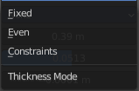
Choose the kind of thickness handling.

Fixed
The new vertices are always in a fixed distance to the old ones.

Even
Adjusts for sharp corners, but may not always work when more than three faces come together.

Constraints
For up to three faces it is always guaranteed to find an optimal solution.

Boundary
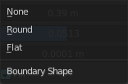
Choose the kind of boundary handling.

None
No boundary fix is applied. Results are stable.

Round
Adjusts the boundary for an opening to face inwards (like a hole in an egg).

Flat
Adjusts the boundary of a planar opening to be a flat (like a cut sphere).

Thickness
The extrude amount.
Important! The modifier thickness is calculated using local vertex coordinates. If the object has a non-uniform scale, the thickness will vary on different sides of the object. To fix this, either Apply or Clear the scale.

Offset
A value between (-1 to 1) to locate the solidified output inside or outside the original mesh. The inside and outside is determined by the face normals. Set to 0.0, the solidified output will be centered on the original mesh.

Merge Threshold
The distance within which degenerated geometry is merged.

Rim
Note! Fill and Only Rim only make a difference on Non-manifold objects, since the rims are generated from the borders of the original geometry.

Fill
Fills the gap between the inner and outer edges.

Only Rim
Will only leave the generated perpendicular rim
Note! Fill and Only Rim only make a difference on Non-manifold objects, since the rims are generated from the borders of the original geometry.

Vertex Group
Only vertices in this group are solidified. Their weights are multiplied by the thickness, so vertices with lower weights will be less thick.

Invert
Reverses the vertex group, so that only vertices which are not in the vertex group are solidified.

Factor
How much the vertex weights are taken into account. You need to have a vertex group assigned to activate this item.
On 0.0, vertices with zero weight will have no thickness at all (creates duplicate vertices).
On 0.5, vertices with zero weight will be half as thick as those with full weight.
On 1.0 , the weights are ignored and the Thickness value is used for every vertex.

Flat Faces
Just in Complex Mode. Use the minimal vertex weight assigned to the vertices of a face to make sure that new faces stays parallel to their original ones. This is slow, so disable it when it is not needed.

Normals

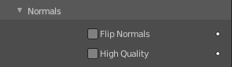
Flip Normals
Reverse the normals of all geometry (both the inner and outer surfaces).

High Quality Normals
Just Simple Mode. Normals are calculated to produce a more even thickness.

Materials

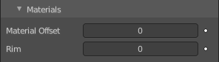
Material Offset
Choose a different material for the new geometry. This is applied as an offset from the original material of the face from which it was solidified.
A value of 0 means it will use the same material.
A value of 1 means it will use the material immediately below the original material.
A value of -2 means the material two positions above the original material will be used.
These values are clamped to the top-most and bottom-most material slots.

Rim
Choose a different material for the rim faces.

Edge Data
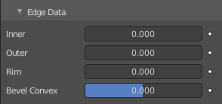
Inner, Outer and Rim are simple mode only.

Inner
Set a crease to the inner edges.

Outer
Set a crease to the outer edges.

Rim
Set a crease to the rim.

Bevel Convex
Edge bevel weight to be added to outside edges.

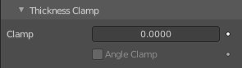
Thickness Clamp

Clamp
A value between (0 to 2) to clamp offsets to avoid self-intersection. The amount is determined by the length of the shortest adjacent edge.

Angle Clamp
If enabled clamping will also consider angles in the geometry, not only lengths. Becomes active when the clamp value is above 0.0.

Output Vertex Groups

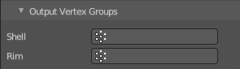
Shell
Vertex group that the generated shell geometry will be weighted to. This allows you to use other modifiers to only affect the shell geometry by using a that modifier’s vertex group influence control.

Rim
Same as Shell Vertex Group, but for the generated rim geometry.

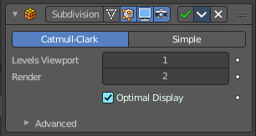
Subdivision Surface
The Subdivision Surface modifier subdivides the faces of the mesh. With Simple it just divides the faces. The Catmull-Clark algorithm allows you to smoothen the result.

Type

Catmull-Clark
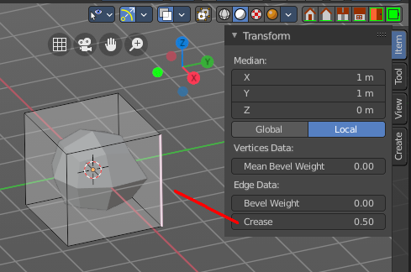
Subdivides and smooths the surfaces.
Note! Catmull-Clark subdivision rounds off edges. And sometimes this is not what you want. There are several solutions that allow you to control the subdivision. You can add a so called support edge or a support loop to keep the edge sharp.
Or you can change the crease of the edges in question. Edge Crease can be adjusted in the Transform panel in the Item tab of the sidebar in the 3D view. You need to be in Edit mode.
Note! Abrupt normal changes in the surface can produce ugly black gouges, even when these flipped normals are not an issue for the shape itself. A quick way to fix this is to use the Recalculate Normals operation in Edit Mode. If you still have some ugly black gouges you can try to manually flip the normals in question.

Simple
Only subdivides the surfaces, without any smoothing.

Levels Viewport
The number of subdivision levels shown in the 3D Viewport.

Render
The number of subdivision levels shown in the final render.

Optimal Display
When rendering the wire frame of this object, the wires of the new subdivided edges will be skipped. Only the edges of the original geometry will be displayed.

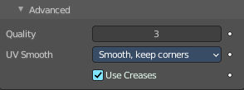
Advanced

Quality
How precisely the vertices are positioned, relatively to their theoretical position of an infinitely subdivided mesh.
Note! This value can have an affect on how accurate Edge Creases can be. Using a higher Quality value will allow for a wider range of crease values to work accurately.

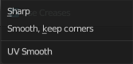
UV Smooth
How to handle UV's during subdivision.

Smooth, keep corners
UV islands are smoothed, but their boundary remain sharp.

Sharp
UV remain unchanged.

Use Creases
Use the Weighted Edge Creases values stored in edges to control the smoothness of the edges.

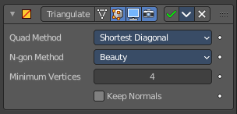
Triangulate
The Triangulate modifier triangulates all faces in a mesh.

Quad Method
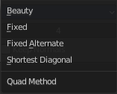
How to triangulate quads.

Beauty
Tries to split the quads in a way that takes the topology into account.

Fixed
Split the quads on their 1st and 3rd vertices.

Fixed Alternate
Split the quads on their 2nd and 4th vertices.

Shortest Diagonal
Split the quads based on the diagonal distance between their vertices.

Polygon Method
How to triangulate N-Gons.

Beauty
Tries to split the N-Gons in a way that takes the topology into account.

Clip
Split the N-Gons by using an ear-clipping algorithm

Minimum Vertices
Minimum number of vertices a face must have to be triangulated. For example, setting this value to 5, will prevent triangulation of Quads and only triangulate N-gons.

Keep Normals
When using custom normals, try to preserve the same shading as before triangulation.

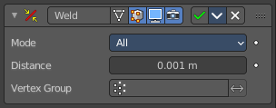
Weld
The Weld modifier merges vertices within a threshold.

Mode

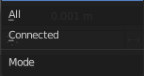
All
Full merge by distance.

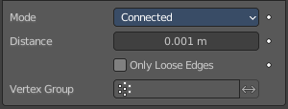
Connected
Just along the edges.

Distance
The maximum distance to merge vertices.

Only Loose Edges
Just with Connected. Welds only loose edges.

Vertex Group
Only merge vertices from this vertex group.

Invert
Inverts the influence of the selected vertex group. Only vertices outside of this vertex group will be merged.

